Name:  Teacher: | ____________________________________  ________________ |  | Date:_________
 | Year 10 Mathematics  SCORE:  / 21  Mini test 6  Topic – Pythagoras  Full working out MUST be shown to get full marks for each question.
Total Time: | 35 minutes
Weighting: | 5 %
Equipment: | To be provided by the student: Pens and Pencils, scientific calculator, ruler and a A4 page of notes.

Multi-choice Questions; ( 5 marks )

Question1.

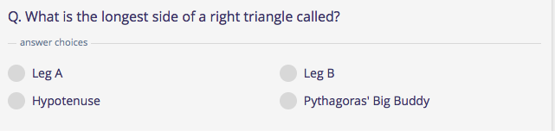

Question2.

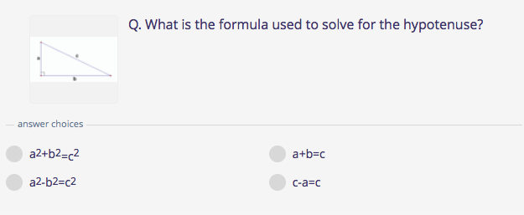

Question 3.
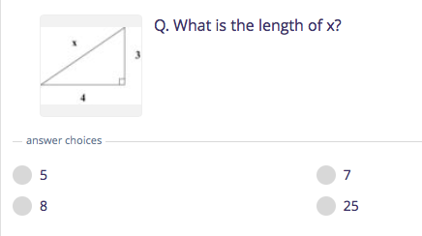

Question 4

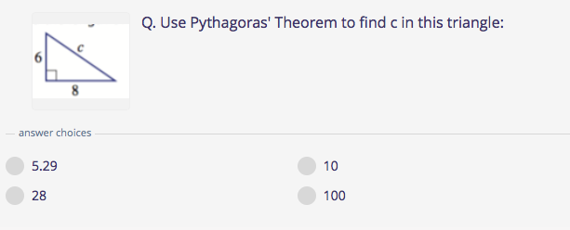

Question 5.

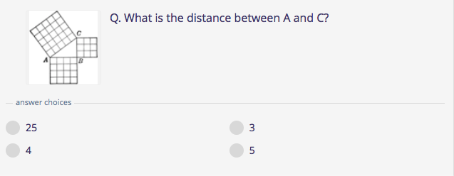

Short answer questions. SHOW ALL WORKINGS.

Question 6. ( 3marks )

What is the length of the missing side?

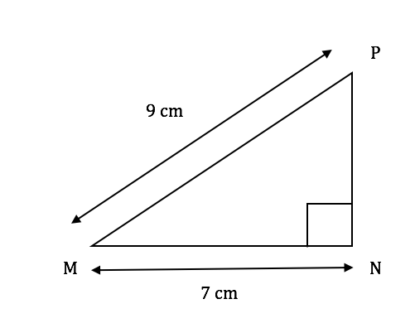

Question 7. ( 4 marks )
David leaves the house to go to school. He walks 300m west and 175m north. How far away is he from his starting point? (the diagonal). Draw a diagram and show all workings.

Question 8.

Calculate the perimeter of the following shape: (5 marks )

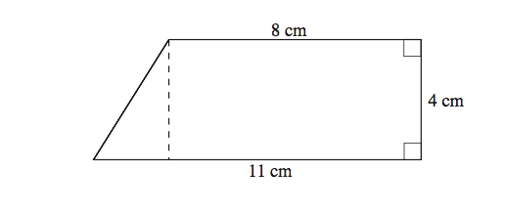

Question 9. ( 4 marks )

If a fireman has a ladder that is 13 metres long. If he wants to reach a window that is 12 metres above the ground, how far from the wall should he put the bottom of his ladder? Draw a diagram and show all workings.

The End

